

Bellabeat Fitness Tracker

Data Analysis

Report

Author : Albert Klein

Data Analytics [albertklein08@gmail.com](mailto:albertklein08@gmail.com)

*The aim of this project was to analyze fitness tracking data from the Bellabeat Fitness Tracker Data to identify trends and patterns in smart device usage and relate these to Bellabeat's products to improve their marketing strategy and overall business growth. Using Google's 6 step data analytics process, we asked relevant questions about the data, prepared and processed the dataset using RStudio, analyzed the data, and shared our findings and recommendations with the Bellabeat stakeholders.*

Introduction: 3

**Ask** 5

**Prepare** 6

**Process** 6

Data cleaning 8

Data Modelling 9

**Analyze** 10

**Initial Analysis** 11

**1. How often do users use their devices in a month?** 11

Visualization: 11

Analysis: 12

Recommendations for Bellabeat: 12

**2. Time spent in bed vs time spent asleep** 13

Visualization: 14

Recommendations for Bellabeat: 14

Visualization: 16

Recommendations for Bellabeat: 17

**3. The relationship between steps and amount of sleep** 18

Visualization: 18

Recommendations for Bellabeat: 19

**4. On which days of the week are users most active?** 20

Visualizations: 20

Recommendations for Bellabeat: 21

**5. Which times of the day are users most active?** 22

Visualization: 22

Recommendations for Bellabeat: 23

**Share** 24

Recommendations for Bellabeat: 24

**Act:** 25

### Introduction:

In recent years, the fitness industry has seen a surge in demand for health-focused smart products. Bellabeat, a high-tech company, has established itself as a key player in this market by manufacturing fitness tracking devices that cater specifically to women.

Bellabeat is a company that aims to empower women by providing innovative health and wellness products. Their mission is to improve the overall well-being of women by giving them the knowledge and tools to understand and take control of their health. Through their range of fitness trackers and smart jewelry, Bellabeat enables women to track their activity levels, monitor their sleep patterns, manage stress, and improve their overall lifestyle.

One of Bellabeat's key products is the fitness tracker. These trackers are designed to seamlessly integrate into a woman's everyday life, allowing her to monitor her physical activity, such as steps taken, distance covered, and calories burned. The trackers also provide insights into sleep quality, helping women understand their sleep patterns and adjust to improve restfulness.

Bellabeat's fitness trackers are not limited to traditional wristbands. They also offer smart jewelry options that can be worn as necklaces or bracelets. These stylish pieces not only track activity and sleep but also serve as a fashionable accessory. This combination of functionality and fashion is a unique aspect of Bellabeat's products, catering to women who prioritize both style and health.

To complement the fitness trackers and smart jewelry, Bellabeat provides a mobile app that connects seamlessly with the devices. The app acts as a central hub for data collection and analysis, allowing users to view their activity, sleep, and stress levels in real-time. It also offers personalized insights and recommendations based on the data collected, helping women make informed decisions about their health and wellness.

Bellabeat also acknowledges the importance of mental health and stress management. Their products incorporate features that enable women to track their stress levels and practice guided breathing exercises to promote relaxation and mindfulness. By addressing both physical and mental well-being, Bellabeat strives to provide a holistic approach to women's health.

The company's website, https://bellabeat.com/about-us/, serves as a comprehensive resource for customers, providing detailed information about their products, features, and the science behind their technology. It also offers a supportive community where women can connect with like-minded individuals and share their health journeys.

###### **Google's Data Analytics process summary:**

**Ask:**

The first step is to define the problem statement and ask relevant questions that the analysis should answer. In this case, the objective is to identify trends and patterns in the usage of Bellabeat's fitness tracking devices to identify potential opportunities for growth in the industry.

**Prepare:**

In the second step, data is gathered from various sources and prepared for analysis. This includes cleaning and transforming the data to ensure its accuracy and suitability for analysis.

**Process:**

The third step involves organizing and manipulating the data to make it suitable for analysis. This includes sorting, filtering, and grouping the data as needed.

**Analyze:**

In the fourth step, the prepared data is analyzed using statistical methods and visualizations to identify trends and patterns. This step involves exploring correlations between different metrics to derive insights.

**Share:**

In the fifth step, the findings from the analysis are presented in a comprehensive report that is easily understood by stakeholders. This step involves communicating the insights in a clear and concise manner.

**Act:**

In the final step, the recommendations based on the analysis are implemented to drive business growth. This step involves taking action based on the insights derived from the analysis and monitoring the impact of those actions on the business.

#### 

#### 

#### 

#### 

#### **Ask**

**Business Task**

Find trends and patterns in smart device usage and then relate these trends to the Bellabeat products to help improve the marketing strategy and the overall business growth of Bellabeat.

**Questions that will guide our Analysis:**

1. What are some trends in smart device usage?

2. How could these trends apply to Bellabeat customers?

3. How could these trends help influence Bellabeat marketing strategy?

#### **Prepare**

Dataset Source

The data source used for our case study is Fitbit Fitness Tracker Data. This dataset is stored in Kaggle and was made available through Mobius. It is an Open-Source dataset. This data set contains personal fitness trackers from thirty Fitbit users.

Dataset Organization

There is a total of 18 .CSV files. Each subject has a unique ID and the data is recorded with a date and time stamp. Each row in the data is a new observation and this results in the data being in long format.

Dataset Integrity

The data only has thirty participants, which is the minimum sample size for a decent analysis. There is sampling bias since it does not include any gender information. This could mean that the data might include data for men, which is not useful for Bellabeat. The data also only covers 1 month of activity which is a noticeably brief period for the analysis.

#### **Process**

I will be using RStudio for my analysis because of the size of the data and reproducibility that R offers. R is also useful when visualizing data for stakeholders.

Packages Used for Analysis:

- Tidyverse

- Janitor

- Lubridate

- Skimr

- ggplot2

- ggrepel

- readr

- RcolorBrewer

- data.table

###### 1. Installing packages needed

install.packages('tidyverse')

install.packages('janitor')

install.packages('lubridate')

install.packages('skimr')

install.packages('ggplot2')

install.packages('readr')

install.packages("ggrepel")

install.packages("RColorBrewer")

install.packages("data.table")

###### 2. Loading packages installed

library(tidyverse)

library(janitor)

library(lubridate)

library(skimr)

library(ggplot2)

library(readr)

library(ggrepel)

library(RColorBrewer)

library(data.table)

###### 3. Importing datasets needed for analysis

daily_activity <- fread("https://raw.githubusercontent.com/AlbertData/Datasets/main/Raw%20Datasets/BellaBeat%20Fitness%20Dataset/dailyActivity_merged.csv")

daily_sleep <- fread("https://raw.githubusercontent.com/AlbertData/Datasets/main/Raw%20Datasets/BellaBeat%20Fitness%20Dataset/sleepDay_merged.csv")

daily_steps <- fread("https://raw.githubusercontent.com/AlbertData/Datasets/main/Raw%20Datasets/BellaBeat%20Fitness%20Dataset/dailySteps_merged.csv")

hourly_steps <- fread("https://raw.githubusercontent.com/AlbertData/Datasets/main/Raw%20Datasets/BellaBeat%20Fitness%20Dataset/hourlySteps_merged.csv")

###### 4. Preview raw data

View(daily_activity)

View(daily_sleep)

View(daily_steps)

View(hourly_steps)

###### First impressions of the data:

daily_activity: 15 columns \* 940 Rows (33 unique id's, 0 duplicates)

daily_sleep: 5 columns \* 413 Rows (24 unique id's, 3 duplicates)

daily_steps: 3 columns \* 940 Rows (33 unique id's, 0 duplicates)

hourly_steps: 3 columns \* 22099 Rows (33 unique id's, 0 duplicates)

*\*Data includes column names with upper and lowercase letters as well as duplicates and inconsistent dates.*

#### Data cleaning

**Correcting consistency of the date formats**

daily_activity <- daily_activity %>%

rename(date = ActivityDate) %>%

mutate(date = as_date(date, format = "%m/%d/%Y"))

daily_sleep <- daily_sleep %>%

rename(date = SleepDay) %>%

mutate(date = as_date(date, format = "%m/%d/%Y %I:%M:%S %p"))

daily_steps <- daily_steps %>%

rename(date = ActivityDay) %>%

mutate(date = as_date(date, format = "%m/%d/%Y"))

hourly_steps <- hourly_steps %>%

rename(date_time = ActivityHour) %>%

mutate(date_time = as.POSIXct(date_time,

format = "%m/%d/%Y %I:%M:%S %p", tz = Sys.timezone()))

**Cleaning column names**

names(daily_activity) <- tolower(names(daily_activity))

names(daily_sleep) <- tolower(names(daily_sleep))

names(daily_steps) <- tolower(names(daily_steps))

names(hourly_steps) <- tolower(names(hourly_steps))

**Removing duplicates**

daily_sleep <- distinct(daily_sleep)

View(sum(duplicated(daily_sleep)))

#### Data Modelling

**Merging data from daily_activity and daily_sleep**

daily_activity_sleep <- merge(daily_activity, daily_sleep, by = c('Id','date'))

**Adding a column for week days**

daily_activity_sleep <- daily_activity_sleep %>%

mutate(week_day = weekdays(date))

names(daily_activity_sleep) <- tolower(names(daily_activity_sleep))

**Summary of data**

summarise(daily_activity)

summarise(daily_sleep)

summarise(daily_steps)

summarise(daily_intensities)

summarise(hourly_steps)

summarise(daily_activity_sleep)

#### **Analyze**

**Questions we will be asking to identify trends and patterns:**

1. How often do users use their devices in a month?

2. Time spent in bed vs time spent asleep

3. The relationship between steps and amount of sleep

4. On which days of the week are users most active?

5. Which times of the day are users most active?

##### **Initial Analysis**

Upon taking a quick glance at the data, several observations can be made regarding smart device usage patterns.

Firstly, there is a positive correlation between the number of steps taken and the amount of sleep obtained, indicating a potential relationship between physical activity and sleep quality.

Additionally, the data reveals that users are most active on Saturdays, with higher average steps recorded on this day compared to other days of the week. Furthermore, when examining the hourly activity levels, it is evident that users are most active during the daytime hours, with peak activity observed between 8:00 AM and 10:00 AM.

These initial observations suggest that users are engaged with their smart fitness devices, demonstrating a willingness to track their physical activity and sleep patterns. Further analysis is required to delve deeper into these trends and understand their implications for Bellabeat's customers and marketing strategy.

##### **1. How often do users use their devices in a month?**

View Code:

user_category <- daily_activity %>%

group_by(id) %>%

summarise(days_used = n())

usertype <- user_category %>%

mutate(usage = case_when(

days_used >= 0 & days_used < 15 ~ "0 - 15 Days ~ Rarely",

days_used >= 15 & days_used < 25 ~ "15 - 25 Days ~ Often",

days_used >= 25 ~ "25+ Days ~ Regularly"))

category_counts <- table(usertype$usage)

total_entries <- sum(category_counts)

usage_percentages <- prop.table(category_counts) * 100

usage_table <- as.data.frame(usage_percentages)

usage_table <- usage_table %>%

arrange(Freq)

View(usage_table)

Visualization:

palette <- brewer.pal(11, "Spectral")

selected_colors <- palette[9:11]

plot1 <- ggplot(usage_table, aes(x = "", y = Freq, fill = factor(Var1))) +

geom_bar(width = 1, stat = "identity") +

coord_polar("y", start = 1100) +

theme_void() +

theme(legend.position = "right",

legend.key.size = unit(2, 'cm'),

legend.title = element_text(size=23),

legend.text = element_text(size=24)) +

labs(fill = "How often do users use their devices")

plot1A <- plot1 +

geom_rect(aes(xmin = -0.1, xmax = -0.6, ymin = -0.0005, ymax = -0.001), fill = "white", color = NA)+

scale_fill_manual(values = selected_colors)+

annotate("text", x = 1, y = 1, label = "9.1%",

vjust = -3.5, hjust = 1.65,

color = "#000000", size = 8.2, angle = 2, fontface = 2) +

annotate("text", x = 1, y = 1, label = "3%",

vjust = -2.8, hjust = 0.9,

color = "#000000", size = 8.2, angle = 340, fontface = 2) +

annotate("text", x = 1, y = 1, label = "87.9%",

vjust = -6, hjust = 2.25,

color = "#000000", size = 8.2, angle = 30, fontface = 2)

print(plot1A)

##### Visualization:

##### Analysis:

Based on the provided data of the frequency of smart device usage, we can observe the following trends:

Majority of users (87.88%) use their smart devices regularly, indicating a prominent level of engagement and consistent usage. This suggests that Bellabeat's customers are actively incorporating the devices into their daily routines and relying on them for tracking their health and wellness.

A sizable portion of users (9.09%) reported using the devices often, implying a moderate level of engagement. These users may have occasional breaks or lower usage frequency but still find value in the device and use it consistently.

A small percentage of users (3.03%) reported using the devices rarely, indicating that there might be a group of customers who are not utilizing the devices to their full potential. It could be beneficial for Bellabeat to investigate the reasons behind this lower usage and explore strategies to encourage greater engagement among these users.

##### Recommendations for Bellabeat:

**Enhance user education and onboarding:** To increase engagement and usage, Bellabeat should focus on providing comprehensive resources, tutorials, and guides to help users understand the full capabilities of the smart devices. This can include video tutorials, FAQs, and online support to address any potential barriers or confusion that might hinder users from fully utilizing the devices.

**Gamification and goal setting:** Implementing gamification elements, such as challenges, badges, and rewards, can incentivize users to engage more frequently with their devices. Bellabeat can encourage users to set and track goals, offering personalized recommendations and celebrating milestones to enhance motivation and long-term engagement.

**Personalized marketing campaigns:** Leverage the insights gained from user data to tailor marketing campaigns that highlight specific features and benefits that align with different user segments. For example, promoting the stress management capabilities to users who have lower engagement and emphasizing the activity tracking features to those who are more active. Personalized messaging can resonate with users and increase their motivation to use the devices regularly.

Reference:

To support the recommendation of personalized marketing campaigns, Bellabeat can refer to the article "The Power of Personalization" published by McKinsey & Company (https://www.mckinsey.com/business-functions/marketing-and-sales/our-insights/the-power-of-personalization). The article emphasizes the importance of delivering personalized experiences to customers and outlines strategies for implementing effective personalized marketing campaigns.

##### **2. Time spent in bed vs time spent asleep**

View code:

time_to_sleep <- daily_sleep %>%

mutate(time_taken = (totaltimeinbed - totalminutesasleep)- 5)

total_minutes_asleep_in_bed <- time_to_sleep %>%

group_by(id) %>%

summarize(total_time_in_bed = sum(totaltimeinbed),

total_minutes_asleep = sum(totalminutesasleep),

total_time_taken_to_sleep = (sum(time_taken)),

count_entries = sum(n()))

avgs_minutes_taken <- total_minutes_asleep_in_bed %>%

group_by(id) %>%

summarize(avg_time_in_bed= total_time_in_bed / count_entries,

avg_minutes_asleep= total_minutes_asleep / count_entries,

avg_minutes_taken_to_sleep= total_time_taken_to_sleep / count_entries)

avgs_minutes_sleeping <- avgs_minutes_taken %>%

filter(avg_minutes_taken_to_sleep >= 0) %>%

mutate(user_number = row_number())

avgs_minutes_sleep <- avgs_minutes_sleeping %>%

filter(avg_minutes_taken_to_sleep >= 0)

avgs_of_minutes_taken <- arrange(avgs_minutes_sleep, avg_minutes_taken_to_sleep)

avgs_of_minutes_taken$user_number <- factor(avgs_of_minutes_taken$user_number)

avgs_minutes_sleeping <- arrange(avgs_minutes_sleeping, avg_time_in_bed)

View(avgs_minutes_sleeping)

View(avgs_of_minutes_taken)

Visualization:

plot2A <- ggplot(avgs_minutes_sleeping, aes(x = reorder(user_number, avg_minutes_asleep)),

y = avg_time_in_bed) +

geom_bar(aes(fill = "avg_minutes_in_bed", y = avg_time_in_bed), stat = "identity",

color = "#1fc0ff") +

geom_bar(aes(fill = "avg_minutes_asleep", y = avg_minutes_asleep),

stat = "identity", color = "#28ff77") +

scale_fill_manual(values = c("avg_minutes_in_bed" = "#3434ff",

"avg_minutes_asleep" = "#29ff34"),

labels = c("Minutes Asleep", "Minutes In Bed")) +

coord_fixed(ratio = 0.015) +

theme_bw()+

scale_y_continuous(limits = c(0, 1000), breaks = seq(0, 1000, by = 50))+

labs(fill = "",

title = "Time spent in bed vs Time spent asleep",

x = "User",

y = "Minutes")+

theme(axis.text.x = element_text(size = 12),

axis.text.y = element_text(size = 12),

axis.title.y = element_text(size = 18),

axis.title.x = element_text(size = 18),

plot.title = element_text(size = 20, face = "bold"),

legend.key.size = unit(1, 'cm'),

legend.title = element_text(size=18),

legend.text = element_text(size=20))

print(plot2A)

plot2B <- ggplot(avgs_of_minutes_taken, aes(x = reorder(user_number,

avg_minutes_taken_to_sleep),

y = avg_minutes_taken_to_sleep)) +

geom_point(color = "purple", size = 5) +

geom_segment(aes(x = user_number, xend = user_number,

y = 0, yend = (avg_minutes_taken_to_sleep - 0.5)),

color = "#f9952b", size = 1.5)+

coord_fixed(ratio = 0.28) +

theme_light()+

scale_y_continuous(limits = c(0, 50), breaks = seq(0, 50, by = 5))+

labs(title = "Average Time Taken To Fall Asleep",

x = "User",

y = "Minutes") +

theme(axis.text.x = element_text(size = 15),

axis.text.y = element_text(size = 15),

axis.title.y = element_text(size = 20),

axis.title.x = element_text(size = 20),

plot.title = element_text(size = 20, face = "bold"))

print(plot2B)

##### Visualization:

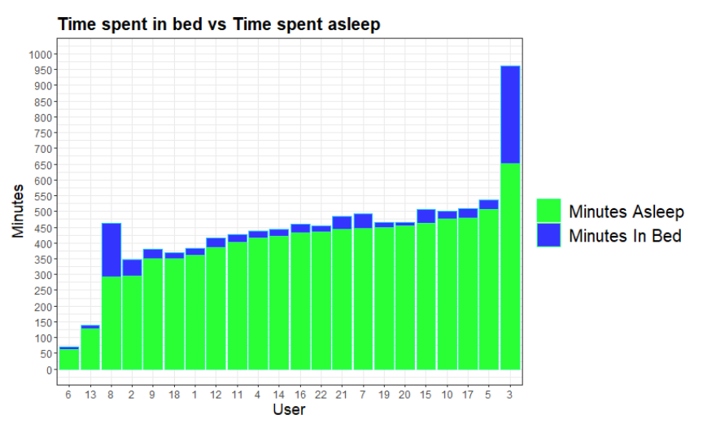

Analyzing the provided data on time spent in bed versus time spent asleep, we can derive the following insights:

**Average time spent in bed:** The data indicates that users spend varying durations in bed, ranging from 69 minutes to 961 minutes (approximately 1 hour and 9 minutes to 16 hours and 1 minute). The average time spent in bed among the users is around 453 minutes (approximately 7 hours and 33 minutes).

**Average minutes asleep:** Users, on average, spend approximately 435 to 652 minutes (approximately 7 hours and 15 minutes to 10 hours and 52 minutes) asleep. The average minutes asleep across the users is approximately 467 minutes (approximately 7 hours and 47 minutes).

**Average minutes taken to sleep**: The data reveals that users take varying amounts of time to fall asleep, ranging from 3 minutes to 304 minutes (approximately 3 seconds to 5 hours and 4 minutes). The average time taken to fall asleep among the users is around 26 minutes.

##### Recommendations for Bellabeat:

**Sleep Duration Analysis:** Bellabeat can utilize this data to gain a better understanding of users' sleep patterns. By analyzing the differences between the average time spent in bed and the average minutes asleep, Bellabeat can identify users who have longer bed durations but shorter actual sleep durations. This information can help the company develop features and functionalities that encourage users to optimize their sleep quality and improve their overall well-being.

**Sleep Efficiency**: Bellabeat can calculate sleep efficiency by dividing the average minutes asleep by the average time spent in bed. This metric provides insights into how effectively users are utilizing their time in bed for sleep. Users with lower sleep efficiency may benefit from personalized recommendations and interventions aimed at improving sleep hygiene, such as sleep environment optimization and relaxation techniques.

**Sleep Onset Analysis:** The average minutes taken to fall asleep can be valuable for understanding users' sleep initiation patterns. Bellabeat can identify users who consistently take longer to fall asleep and develop features or guided exercises to assist in reducing sleep onset latency. This could involve providing relaxation techniques, bedtime routines, or other strategies to promote a quicker and smoother transition into sleep.

Reference:

To support the recommendation of optimizing sleep quality and its impact on overall well-being, Bellabeat can refer to the publication "Sleep duration and its impact on health: Overview of systematic reviews" by Hirshkowitz et al. (2015), published in the Journal of Clinical Sleep Medicine. The paper provides an overview of various systematic reviews that establish the link between sleep duration and various health outcomes, emphasizing the importance of adequate sleep duration for overall health and well-being.

##### Visualization:

Analyzing the provided data on the average time taken to fall asleep, we can derive the following insights:

**Average time taken to fall asleep:** The data indicates that users have varying durations for falling asleep, ranging from 3 minutes to 304 minutes (3 seconds to 5 hours and 4 minutes). The average time taken to fall asleep among the users is around 26 minutes.

##### Recommendations for Bellabeat:

**Sleep Onset Analysis:** The average time taken to fall asleep is an important metric in understanding users' sleep initiation patterns. Bellabeat can leverage this data to gain insights into users who experience difficulties in falling asleep quickly. By identifying users who consistently take longer to fall asleep, Bellabeat can develop features or guided exercises that aid in reducing sleep onset latency. This could include techniques such as relaxation exercises, soothing soundscapes, or guided meditation to help users achieve a more efficient and restful sleep onset.

**Sleep Environment Optimization:** The time taken to fall asleep can be influenced by several factors, including the sleep environment. Bellabeat can educate users about the importance of optimizing their sleep environment by ensuring a comfortable temperature, reducing noise and light disturbances, and creating a calming ambiance in the bedroom. By providing tips and guidance on creating an ideal sleep environment, Bellabeat can help users improve their sleep onset experience and overall sleep quality.

**Personalized Recommendations:** By analyzing individual sleep patterns and considering factors such as lifestyle, stress levels, and daily routines, Bellabeat can provide personalized recommendations to users to optimize their sleep onset. This could involve tailored suggestions based on the user's specific sleep patterns, such as adjusting bedtime routines, avoiding stimulating activities before sleep, or adopting relaxation techniques to promote a faster and smoother transition into sleep.

Reference:

To support the recommendation of optimizing sleep onset and sleep environment, Bellabeat can refer to the publication "The influence of bedroom environment on sleep quality and duration: An integrative review" by Kamel et al. (2017), published in Sleep Science. The review highlights the impact of the sleep environment on sleep quality and duration, emphasizing the importance of optimizing the bedroom environment for facilitating better sleep. The study provides insights and recommendations for creating an optimal sleep environment to improve sleep onset and overall sleep quality.

##### **3. The relationship between steps and amount of sleep**

View Code:

average_steps_per_day <- daily_steps %>%

group_by(id) %>%

summarize(avg_steps_per_day = mean(steptotal),

total_steps = sum(steptotal))

average_sleep_per_day <- daily_activity_sleep %>%

group_by(id) %>%

summarize(avg_sleep_per_day = mean(totalminutesasleep),

total_sleep = sum(totalminutesasleep))

average_steps_sleep <- merge(average_steps_per_day, average_sleep_per_day, by = "id")

View(average_steps_sleep)

***Visualization:***

plot3 <- ggplot(average_steps_sleep, aes(x= avg_steps_per_day, y= avg_sleep_per_day))+

geom_point(fill = "#f700ff", size = 5, color = "#9d00ff")+

coord_fixed(ratio = 15) +

theme_bw()+

labs(title = "Average Steps Vs Average Sleep",

x= "Average Steps Per Day",

y= "Average Sleep Per Day (Minutes)")+

scale_y_continuous(breaks = c(0, 50, 100, 150, 200, 250, 300, 350,

400, 450, 500, 550, 600, 650, 700))

plot3A <- plot3 +

scale_x_continuous(breaks = seq(0, 15000, by = 1000))+

theme(axis.text.x = element_text(size = 12),

axis.text.y = element_text(size = 12),

axis.title.y = element_text(size = 17),

axis.title.x = element_text(size = 17),

plot.title = element_text(size = 20, face = "bold"))+

annotate('rect', xmin=8000, xmax=12000,

ymin=350, ymax=500,

alpha=.35, fill='#84ff10')+

annotate('rect', xmin=820, xmax=5000,

ymin=50, ymax=658,

alpha=.35, fill='#ff3810e9')

print(plot3A)

##### Visualization:

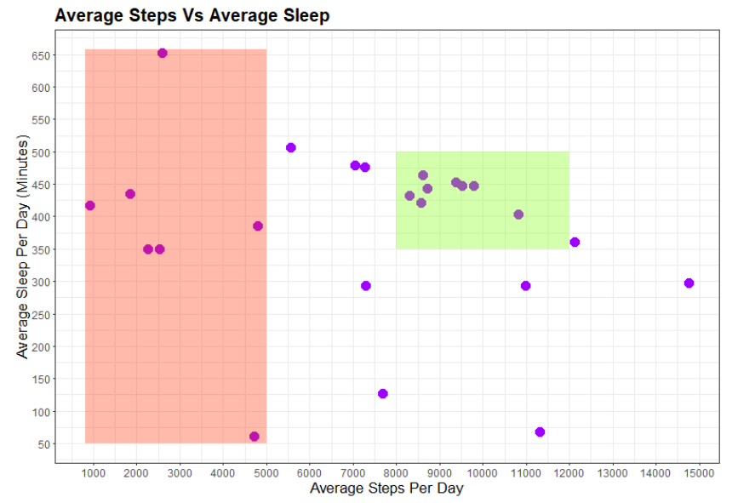

Analyzing the provided data on the relationship between steps and amount of sleep, we can derive the following insights:

**Relationship between Steps and Sleep:** The scatterplot shows the relationship between the average number of steps taken per day and the average amount of sleep per day for Bellabeat users. The data points indicate varying levels of steps and sleep duration among the users.

Shaded areas indicate the following:

**Red Shaded Area:** Users who walked less than 5000 steps per day on average. This suggests that these users may need to increase their daily physical activity levels to achieve better health and sleep outcomes.

**Green Shaded Area:** Users who walked on average between 8000 and 12000 steps per day and slept an average of between 350 and 500 minutes. These users exhibit a healthy balance of activity and sleep, indicating positive lifestyle habits. Bellabeat can promote this range as a target for users to strive for in terms of both steps and sleep duration.

Including these shaded areas in the scatterplot visualization can provide a visual representation of the recommended activity and sleep ranges, encouraging users to align their behavior with the "healthy" category.

##### Recommendations for Bellabeat:

**Encourage Active Lifestyle:** The scatterplot reveals a positive correlation between the number of steps taken and the amount of sleep. Users who engage in higher levels of physical activity, as indicated by a higher average number of steps per day, tend to have better sleep patterns. Bellabeat can leverage this trend to encourage its customers to lead an active lifestyle. Promoting features like step tracking, personalized goal setting, and rewards for achieving step milestones can motivate users to increase their daily physical activity levels, leading to improved sleep quality.

**Sleep and Fitness Challenges**: Bellabeat can organize sleep and fitness challenges for its users, utilizing the insights from the scatterplot. These challenges can encourage users to meet specific step goals while also prioritizing adequate sleep. By incorporating gamification elements, such as leaderboards, rewards, and social sharing options, Bellabeat can create a sense of community and motivation among its users to engage in regular physical activity and achieve optimal sleep patterns.

**Customized Recommendations:** By analyzing individual user data in relation to steps and sleep, Bellabeat can provide personalized recommendations to its customers. This could involve suggesting specific step goals tailored to each user's current activity level and sleep duration. Additionally, Bellabeat can offer sleep coaching tips, highlighting the importance of maintaining an active lifestyle to enhance overall sleep quality and duration.

Reference:

To support the recommendation of promoting an active lifestyle and its positive impact on sleep, Bellabeat can refer to the study "Physical activity and sleep duration in relation to cardiometabolic risk among U.S. adults" by Chaput et al. (2018), published in the journal Sleep Health. The study explores the association between physical activity, sleep duration, and cardiometabolic risk factors. It emphasizes the benefits of regular physical activity on sleep quality and its potential for reducing the risk of cardiometabolic diseases. This research reinforces the importance of incorporating physical activity into daily routines to promote better sleep patterns and overall health.

##### **4. On which days of the week are users most active?**

View Code:

weekday_steps_sleep <- daily_activity_sleep

weekday_steps_sleep$week_day <- ordered(weekday_steps_sleep$week_day,

levels = c("Monday", "Tuesday", "Wednesday",

"Thursday", "Friday", "Saturday",

"Sunday"))

weekday_steps_sleep <- weekday_steps_sleep %>%

group_by(week_day) %>%

summarise(daily_steps = mean(totalsteps),

daily_sleep = mean(totalminutesasleep))

mean_steps <- round(mean(weekday_steps_sleep$daily_steps))

mean_sleep <- round(mean(weekday_steps_sleep$daily_sleep))

View(weekday_steps_sleep)

***Visualizations:***

plot4A <- ggplot(weekday_steps_sleep) +

geom_col(mapping = aes(week_day, daily_steps), fill = "#00ff99db")+

coord_fixed(ratio = 0.00055)+

theme_minimal()+

labs(title = "Average Steps Taken On Each Day Of The Week", x= "", y= "Steps")+

geom_hline(yintercept = mean_steps, color = "#3d8df7", size = 0.8) +

theme(axis.text.x = element_text(size = 17.5),

axis.text.y = element_text(size = 15),

axis.title.y = element_text(size = 20),

plot.title = element_text(size = 22.5, face = "bold"))+

scale_y_continuous(limits = c(0, 10000), breaks = seq(0, 10000, by = 1000))+

annotate("text", x = 1.2, y = mean_steps,

label = "Average = 8557 steps",

vjust = -0.5, hjust = -1.5,

color = "#070724", size = 5.25)

plot4B <- ggplot(weekday_steps_sleep) +

geom_col(mapping = aes(week_day, daily_sleep), fill = "#57cdf8")+

coord_fixed(ratio = 0.011)+

theme_minimal()+

theme(axis.text.x = element_text(size = 17.5),

axis.text.y = element_text(size = 15),

axis.title.y = element_text(size = 18),

plot.title = element_text(size = 22.5, face = "bold"))+

labs(title = "Sleep per day of the week", x= "", y= "Sleep (in minutes)")+

geom_hline(yintercept = mean_sleep, color = "#00a53a", size = 1)+

scale_y_continuous(limits = c(0, 460), breaks = seq(0, 460, by = 25))+

annotate("text", x = 1.2, y = mean_sleep,

label = "Average = 420 minutes",

vjust = -0.5, hjust = -1.75,

color = "#070724", size = 5.25)

##### Visualizations:

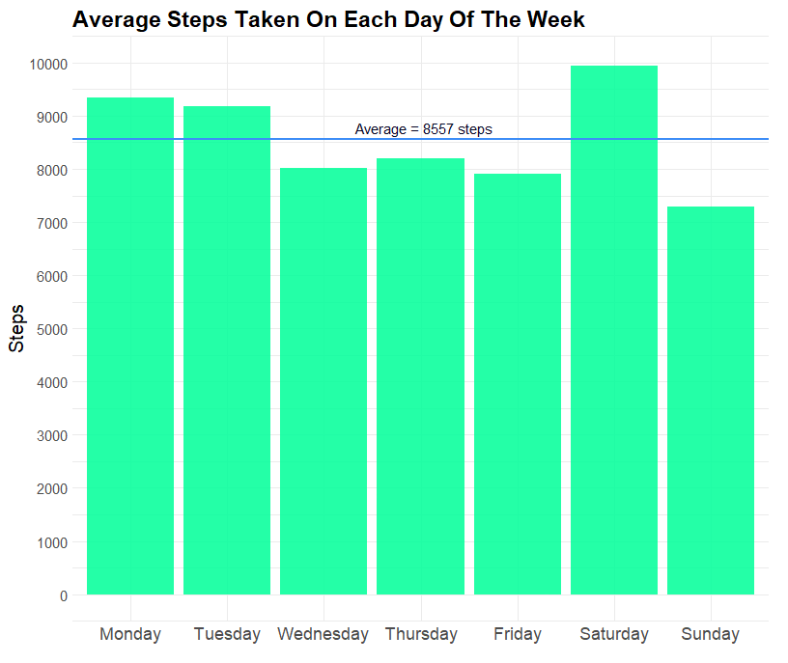

Upon analyzing the data on the activity levels of Bellabeat users throughout the week, we can extract the following insights:

**Activity Levels on Different Days of the Week:** The bar chart displays the average number of steps taken and minutes slept by Bellabeat users on each day of the week.

**Average Steps Taken per Day of the Week**: This bar chart shows the average number of steps taken by Bellabeat users on each day of the week. The average across all days is 8,557 steps.

**Average Minutes Slept per Day of the Week:** This bar chart represents the average number of minutes slept by Bellabeat users on each day of the week. The average across all days is 420 minutes.

##### Recommendations for Bellabeat:

**Peak Activity on Saturday:** Users exhibit the highest average number of steps taken on Saturdays, with an average of 9,948 steps. Bellabeat can leverage this trend by organizing weekend challenges or promoting weekend-specific fitness activities to encourage users to maintain their activity levels and engage in active lifestyles during weekends.

**Sleep Patterns on Sunday:** On Sundays, users exhibit the highest average minutes of sleep, with an average of 452.7 minutes. Bellabeat can capitalize on this trend by promoting Sunday as a dedicated rest and recovery day, emphasizing the importance of quality sleep and self-care. This could involve providing sleep-related content, relaxation techniques, or mindfulness exercises to support users in achieving optimal sleep on Sundays.

**Targeted Marketing and Campaigns:** Understanding the peak activity and sleep patterns throughout the week allows Bellabeat to tailor its marketing strategies and campaigns accordingly. For example, on weekdays when users tend to be less active, Bellabeat can introduce targeted promotions, such as lunchtime workouts or office-friendly exercises, to encourage users to incorporate physical activity into their busy schedules. Additionally, campaigns centered around improving sleep quality and creating nighttime routines can be implemented closer to weekends to align with users' higher sleep durations.

Reference:

To support the recommendation of promoting rest and recovery on Sundays, Bellabeat can refer to the article "Sunday as a day of rest and recovery—A review and essay" by Carney, C., et al. (2020), published in the journal Psychology of Religion and Spirituality. The article discusses the cultural and psychological significance of Sundays as a day of rest and recovery, highlighting its potential benefits for mental health and well-being. Incorporating this concept into Bellabeat's marketing strategy can resonate with users and reinforce the importance of prioritizing self-care and quality sleep.

##### **5. Which times of the day are users most active?**

View Code:

steps_per_hour <- hourly_steps %>%

separate(date_time, into = c("date", "time"), sep= " ") %>%

mutate(date = ymd(date), time = ifelse(is.na(time), "00:00",

substr(time, 1, 5)))

stepsperhour <- steps_per_hour %>%

group_by(time) %>%

summarise(avg_steps = mean(steptotal))

View(stepsperhour)

***Visualization:***

plot5 <- ggplot(stepsperhour, aes(x= time, y= avg_steps, fill = avg_steps))+

geom_col()+

coord_fixed(ratio = 0.025)+

theme_minimal()+

labs(title = "Steps walked Each Hour of the Day", x= 'Time of day', y= "Steps")+

theme(axis.text.x = element_text(size = 12),

axis.text.y = element_text(size = 12),

axis.title.y = element_text(size = 17, face = "bold"),

axis.title.x = element_text(size = 17, face = "bold"),

plot.title = element_text(size = 20, face = "bold"))+

labs(fill = "Average Steps")+

scale_y_continuous(expand = c(0, 20), breaks = seq(0, 600, by = 50))+

scale_x_discrete(guide = guide_axis(angle = 90))

##### Visualization:

Upon analyzing the data on the activity levels of a Bellabeat user throughout different times of the day, we can derive the following insights:

**Peak Activity during Morning and Early Evening**: The histogram displays the average number of steps taken by the user during each hour of the day.

##### Recommendations for Bellabeat:

**Morning Exercise Promotion:** The data reveals a significant increase in activity levels starting from 6:00 AM, with peak activity occurring between 8:00 AM and 10:00 AM. Bellabeat can capitalize on this trend by promoting morning exercise routines, providing workout suggestions, or offering incentives for early morning activities. This can encourage users to establish a healthy exercise habit and maximize their activity levels during this active period of the day.

**Afternoon Slump:** Activity levels experience a slight dip during the early afternoon hours, particularly between 2:00 PM and 5:00 PM. Bellabeat can leverage this insight to introduce targeted strategies for overcoming the afternoon slump. For example, they can provide short exercise routines or stretching techniques specifically designed to boost energy levels and combat fatigue during this period. This can serve as a unique selling point for Bellabeat, emphasizing their commitment to supporting women's overall health and well-being throughout the day.

**Evening Wellness Promotion:** Although activity levels taper off after the peak hours, there is still a considerable number of steps taken in the evening, particularly between 6:00 PM and 8:00 PM. Bellabeat can promote wellness activities during this time, such as evening walks, yoga sessions, or meditation exercises. This can align with users' natural inclination to engage in physical activity during these hours and help them unwind, de-stress, and prioritize self-care.

Reference:

To support the recommendation of promoting morning exercise routines, Bellabeat can refer to the article "The Benefits of Morning Exercise" by Hopkins, M. and Matthews, C. (2020), published in the Journal of Clinical Medicine. The article discusses the physiological and psychological benefits of morning exercise, including increased energy levels, improved cognitive function, and enhanced mood throughout the day. By incorporating this research-backed information into their marketing strategy, Bellabeat can encourage users to start their day with physical activity, positioning their smart fitness devices as an essential tool for a healthy morning routine.

Including the histogram in the analysis visualizes the hourly activity levels of the user, enabling Bellabeat to identify the most active periods of the day. This information can guide the development of targeted marketing campaigns and product features that align with users' activity patterns and help them achieve their health and fitness goals effectively throughout the day.

#### **Share**

##### Recommendations for Bellabeat:

**Enhance Personalized Insights:** Utilize the data collected from smart fitness devices to provide users with personalized insights and recommendations. By analyzing user behavior, including activity levels, sleep patterns, and stress levels, Bellabeat can offer tailored suggestions to improve overall health and well-being. This could include reminders to move, personalized workout plans, sleep optimization tips, and stress management techniques. Providing customized feedback and guidance will enhance user engagement and satisfaction, positioning Bellabeat as a leader in personalized health and fitness solutions.

**Expand Targeted Marketing:** Leverage the identified trends and patterns in smart device usage to inform targeted marketing campaigns. Develop messaging and content that resonates with Bellabeat's core audience of women looking to empower their health. Emphasize the unique features and benefits of Bellabeat products, such as the ability to track and analyze activity, sleep, and stress levels, to showcase their value in promoting holistic well-being. Collaborate with influencers, fitness experts, and wellness communities to amplify brand visibility and reach.

**Foster Community Engagement:** Build a strong community around Bellabeat products by creating an online platform or app where users can connect, share their achievements, and support each other's health goals. Encourage users to participate in challenges, set goals, and share their progress. This community engagement will not only enhance user loyalty but also provide valuable user-generated content and insights for further product development.

**Partnerships and Integrations**: Explore partnerships with other health and wellness brands, app developers, or healthcare providers to enhance the value proposition of Bellabeat products. Integration with popular fitness apps, nutrition trackers, or meditation platforms can provide users with a comprehensive health ecosystem and streamline their wellness journey. Collaborating with healthcare professionals or researchers can further validate the effectiveness of Bellabeat products and open doors to new opportunities.

**Continuous Research and Development:** Invest in ongoing research and development to stay at the forefront of the industry. Keep track of emerging trends, technological advancements, and customer feedback to refine existing products and develop new innovative solutions. Conduct user surveys, focus groups, and usability testing to gain insights into user preferences, pain points, and unmet needs. This customer-centric approach will ensure that Bellabeat remains competitive and continues to provide value to its customers.

#### **Act:**

By implementing the recommendations given, Bellabeat can take significant strides towards becoming a trusted brand that empowers women to proactively manage their health and well-being.

To begin with, it is crucial for Bellabeat to leverage the vast amount of data collected from smart fitness devices to gain more comprehensive insights into user behavior and preferences. This data can be further utilized to perform in-depth analysis and extract valuable patterns and trends that may not have been evident initially. By investing in data analytics capabilities and employing advanced techniques such as machine learning and predictive modeling, Bellabeat can unlock even deeper insights that can fuel future product enhancements and marketing strategies.

Bellabeat should prioritize ongoing research and development efforts to stay ahead of the curve in the dynamic health and wellness industry. This involves closely monitoring industry trends, conducting market research, and actively seeking customer feedback to identify evolving user needs and preferences. By investing in innovation and product development, Bellabeat can introduce new features, functionalities, and product lines that align with the changing demands of its target audience. Continuous improvement and innovation will help Bellabeat maintain a competitive edge and capitalize on emerging opportunities in the market.

Furthermore, Bellabeat should actively engage with its user community by creating a platform for interaction, support, and feedback. Encouraging users to share their experiences, achievements, and challenges can foster a sense of belonging and loyalty, strengthening brand advocacy and customer retention. By actively listening to its users, Bellabeat can gain valuable insights into their needs, aspirations, and pain points, allowing for the development of tailored solutions that truly resonate with its target market.

In conclusion, by embracing data-driven decision-making, personalized recommendations, targeted marketing, community engagement, strategic partnerships, continuous research, and development, Bellabeat can position itself as a leader in the industry and unlock potential opportunities for growth. By leveraging comprehensive data analysis, investing in research and innovation, and actively engaging with its user community, Bellabeat can continuously enhance its product offerings, refine its marketing strategies, and empower women to prioritize and optimize their health and well-being.

Disclaimer:

*\*Disclaimer: It is important to note that the findings and recommendations presented in this report are based on a relatively small sample size of 30 participants from the Fitbit Fitness Tracker Data. While efforts were made to ensure the data was accurate and representative, the results may not be applicable to the broader population. Thus, further analysis with a larger and more diverse sample is needed to validate these findings and recommendations.*